**Task 1 -**

Reproduce the following table using CSS positioning (relative or absolute) instead of <table>.

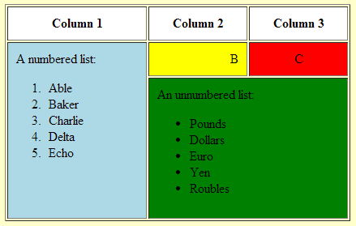

Refer the following sample.

<html>

<head>

<style>

div.blue1 {width:100px;height:200px;background-color:blue;

border-style:none;

position:relative;left:0%;top:0px;}

div.yellow1 {width:100px;height:150px;background-color:yellow;

border-style:none;

position:relative;left:100px;top:-200px;}

div.red1 {width:100px;height:150px;background-color:red;

border-style:none;

position:relative;left:200px;top:-350px;}

div.green1 {width:200px;height:50px;background-color:green;

border-style:none;

position:relative;left:100px;top:-350px;}

</style>

</head>

<body>

<div class = "blue1"></div>

<div class = "yellow1"></div>

<div class = "red1"></div>

<div class = "green1"></div>

</body>

</html>

**Program:**

**<html>**

**<head>**

**<title>Colourful table in html</title>**

**<style>**

**ol>li{list-style: decimal;}**

**ul>li{list-style: circle;}**

**div.maindiv{ width: 822px; height: 525px;**

**background-color: white; border-color: green; border-style: solid; text-align: center;**

**}**

**div.column1{width: 400px; height: 100px;**

**background-color: white;**

**border-color: black; border-style: solid ;**

**position:absolute ; left: 1%; top: 12px;**

**text-align: center;**

**}**

**div.blue1 {width:400px;height:405px;background-color:blue;**

**border-style:inset; border-color: black;**

**position:absolute;left:1%;top:119px;**

**text-decoration-color: Black;**

**text-align: center;}**

**div.column2{width: 200px; height: 100px;**

**background-color: white;**

**border-color: black; border-style: solid;**

**position: absolute; left: 33.2%; top: 12px;**

**text-align: center;**

**}**

**div.yellow1 {width:200px;height:100px;background-color:yellow;**

**border-style:inset; border-color: grey; position:absolute;left:33.2%;top:119px;**

**text-decoration-color: Black; text-align: center; text-padding: 10px;**

**}**

**div.column3{width: 190px; height: 100px;**

**background-color: white;**

**border-color: black; border-style: solid;**

**position: absolute; left: 49.5%; top: 12px;**

**text-align: center;**

**}**

**div.red1 {width:190px;height:100px;background-color:red;**

**border-style:inset; border-color: green;**

**position:absolute;left:49.5%;top:119px;**

**text-decoration-color: Black;**

**text-align: center;}**

**div.green1 {width:400px;height:300px;background-color:green;**

**border-style:outset; border-color: grey;**

**position:absolute;left:33.2%;top:226px;**

**text-decoration-color: Black;**

**text-align: center;}**

**</style>**

**</head>**

**<body>**

**<div class="maindiv"></div>**

**<div class="column1"> Column 1</div>**

**<div class="column2"> Column 2</div>**

**<div class="column3"> Column 3</div>**

**<div class = "blue1"> A numbered list:**

**<ol>**

**<li>Able</li>**

**<li>Baker</li>**

**<li>Charlie</li>**

**<li>Delta</li>**

**<li>Echo</li>**

**</ol>**

**</div>**

**<div class = "yellow1">B</div>**

**<div class = "red1">C</div>**

**<div class = "green1"> An unnumbered list:**

**<ul>**

**<li>Pounds</li>**

**<li>Dollars</li>**

**<li>Euro</li>**

**<li>Yen</li>**

**<li>Roubles</li>**

**</ul>**

**</div>**

**<p> This program is no asked with the padding. If client had asked of it, I would surely made the rearrangement of the box sizes or div sizes and it would only take about an hour.(Taking boringness as a joke.)</p>**

**</body>**

**</html>**

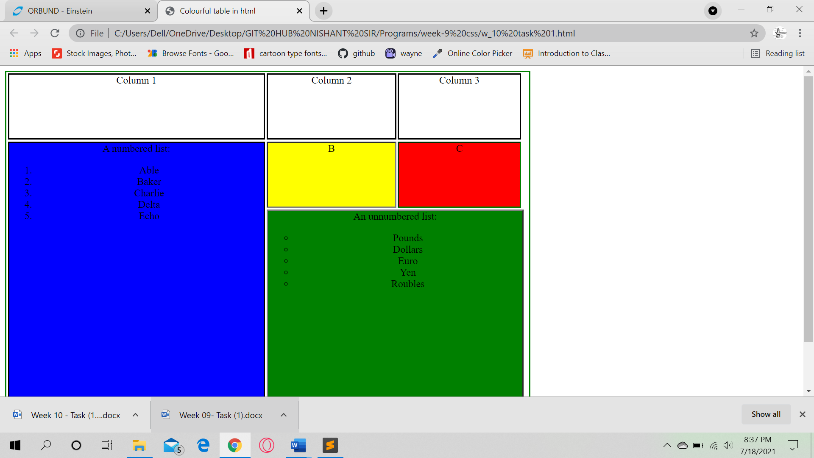

**Task 2 -**

Write the appropriate CSS to change the presentation of the webpage to that shown in figure below. The new page layout includes a header section, two columns (one for navigation menu and one for the main content) and a footer section.

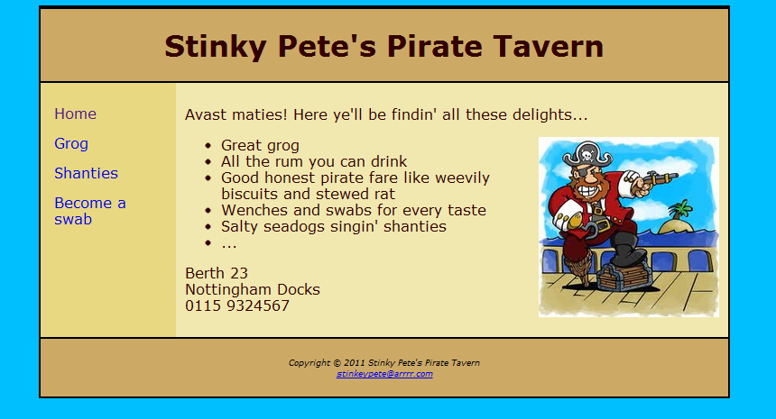

The colours used are as follows:

* Text: #330000
* Body background: #00BFFF
* Header and footer background: #ccaa66
* Left (navigation) column background: #E8D882
* Right (main content) column background: #f1e8b0

The text is displayed in “Verdana” font.

Program:

<!DOCTYPE html>

<html>

<head>

<meta charset="utf-8">

<title>Task 2</title>

<style>

body

{

font-family:verdana;

background-color:#00BFFF;

color:#330000;

}

.main

{

position:relative;

background-color:#f1e8b0;

width:70%; padding: 10px;

height:62%;

display: inline-block;

float: right; position: absolute; top: 110px;

}

header

{

background-color:#ccaa66;

border:2px solid black;

}

footer

{

background-color:#ccaa66;

text-align:center;

border:2px solid black;

padding: 10px;

}

.nav

{

list-style:none;

background:#E8D882;

width:18%;

height: 96%;

float: left;

}

ul li a

{

display:inline-block;

padding: 10px 25px;

color: #333;

text-decoration: none;

}

ul li a:hover

{

color: #fff;

background: #939393;

}

img

{

position:relative;

top:-130px;

right:-385px;

}

.container

{

border:2px solid black;

}

.ul

{

position:relative;

top:22px;

left:9px;

}

.this{

height: 400px;

width: 92%;

display: inline-block;

}

</style>

<body>

<div class="container">

<header>

<h1>Stinky pete's pirate tavern</h1>

</header>

<div class="this">

<ul class="nav">

<li class="li"><a href="#">Home</a></li>

<li class="li"><a href="#">Grog</a></li>

<li class="li"><a href="#">Shanties</a></li>

<li class="li"><a href="#">Become a<br>swab</a></li>

</ul>

<div class="main">

<div class="p2">Avast maties! Here ye'll be findin' all these delights...</div>

<li>Great grog</li>

<li>All the rum you can drink</li>

<li>Good honest pirate fare like weevily<br>biscuits and stewed rat</li>

<li>Wenches and swabs for every taste</li>

<li>Salty seadogs singin' shanties</li>

<li>...</li>

<p></p>

<p>Berth 23<br>Nottingham Docks<br>0115 9324567</p>

<imgsrc="stinky.jpg" height="230" width="125">

</div>

</div>

<footer>

Copyright 2011 Stinky Pete's Pirate traven<br>

<a href="stinkypete@arrrr.com">stinkypete@arrrr.com</a>

</footer>

</div>

</body>

</html>

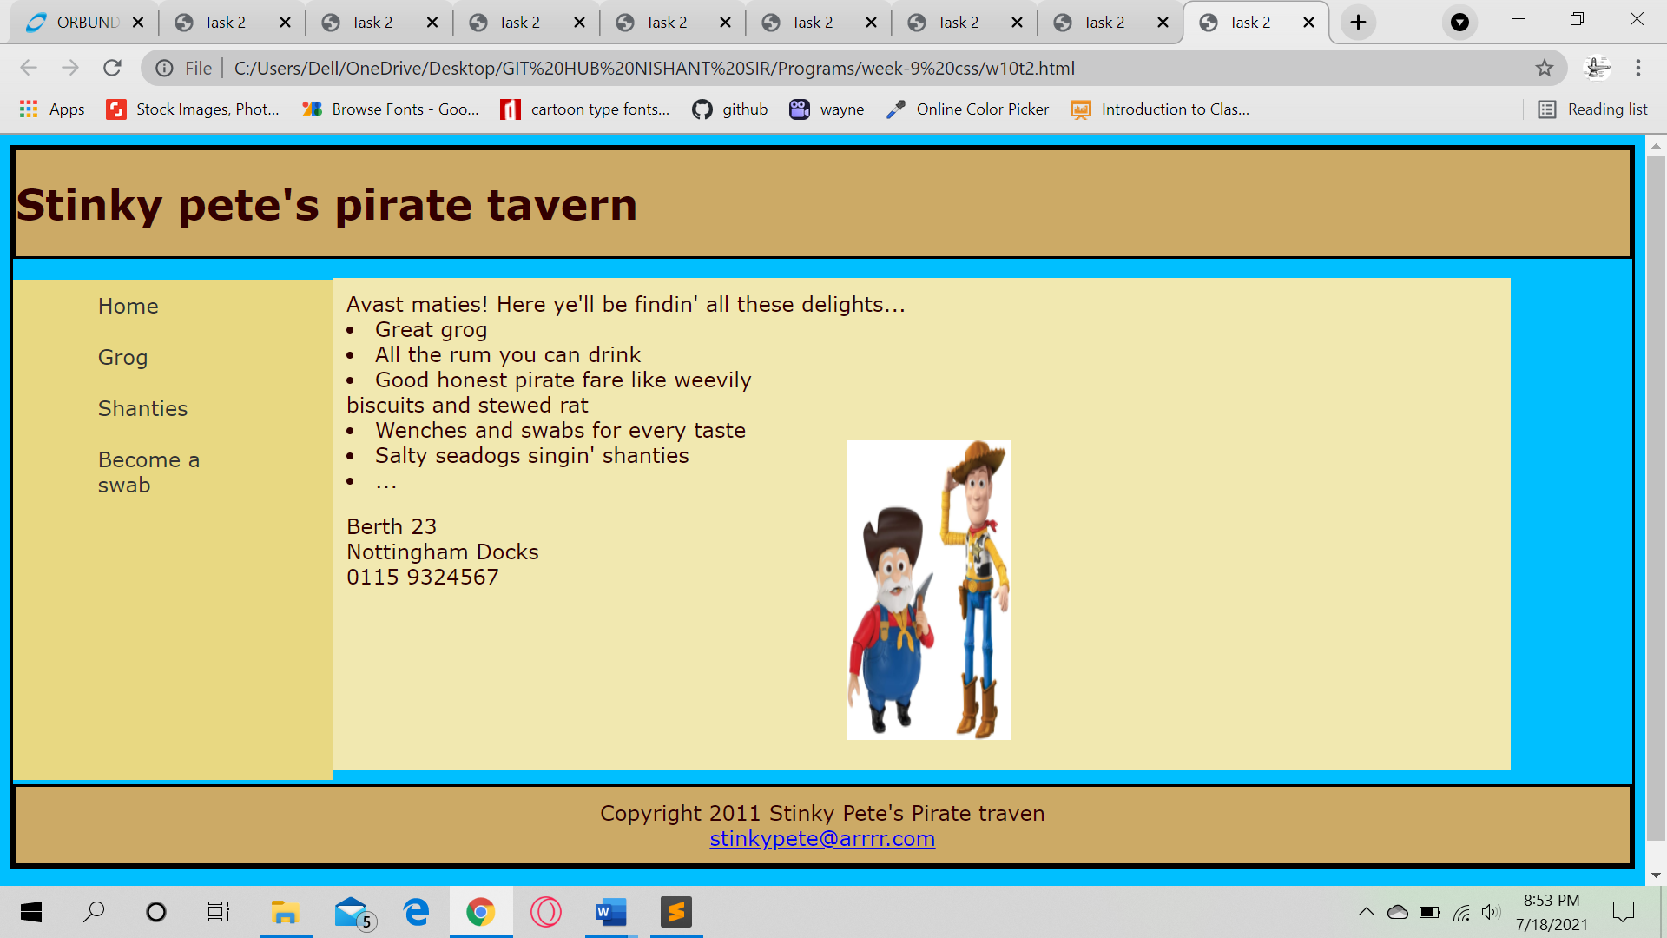

**Task 3- Create the following layout by HTML AND CSS**

